# Library Manager

## Class diagram

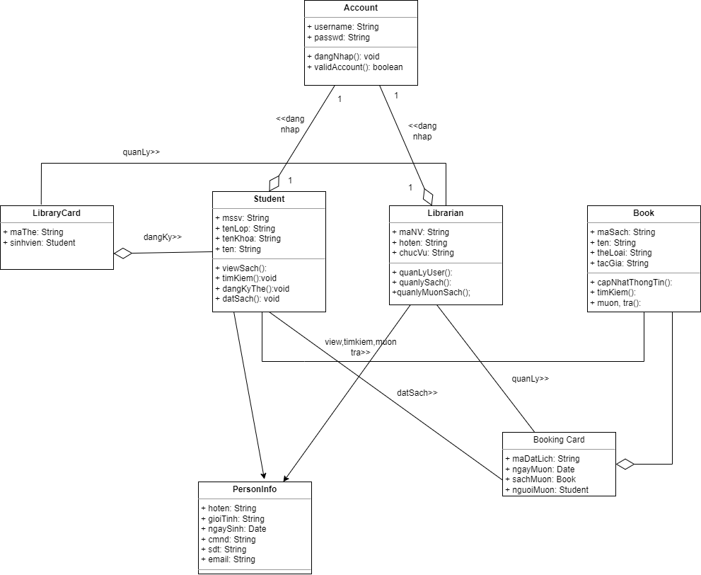

## Sequence Diagram

### Đăng ký

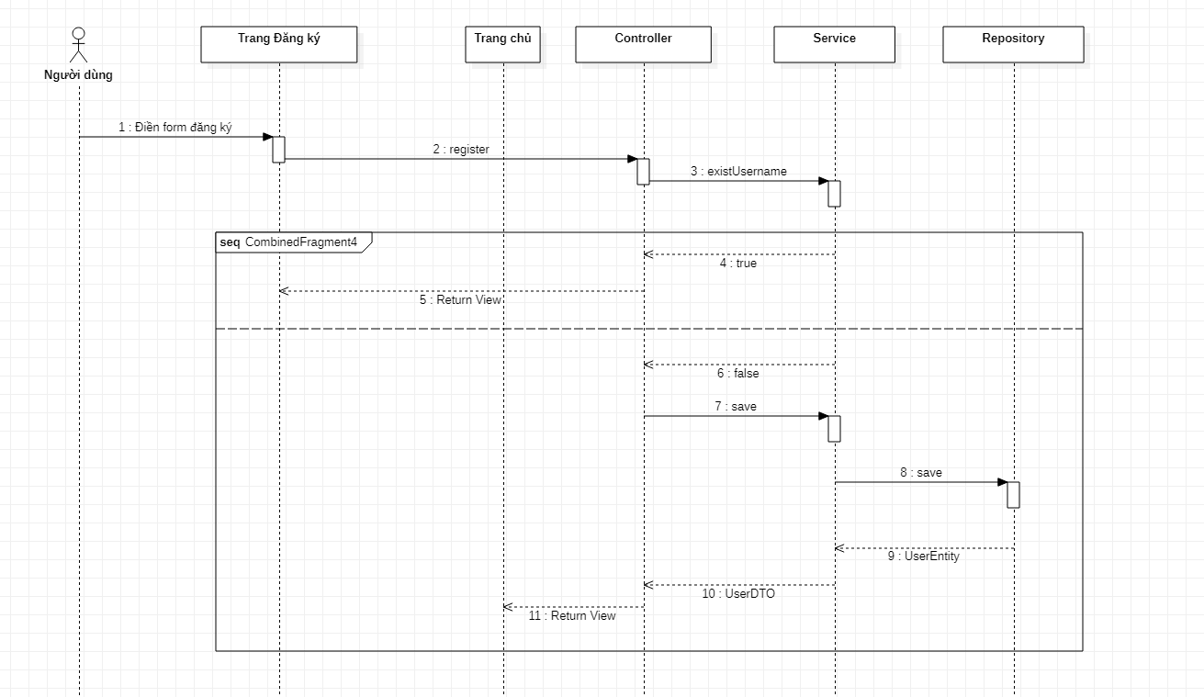

### Đăng nhập

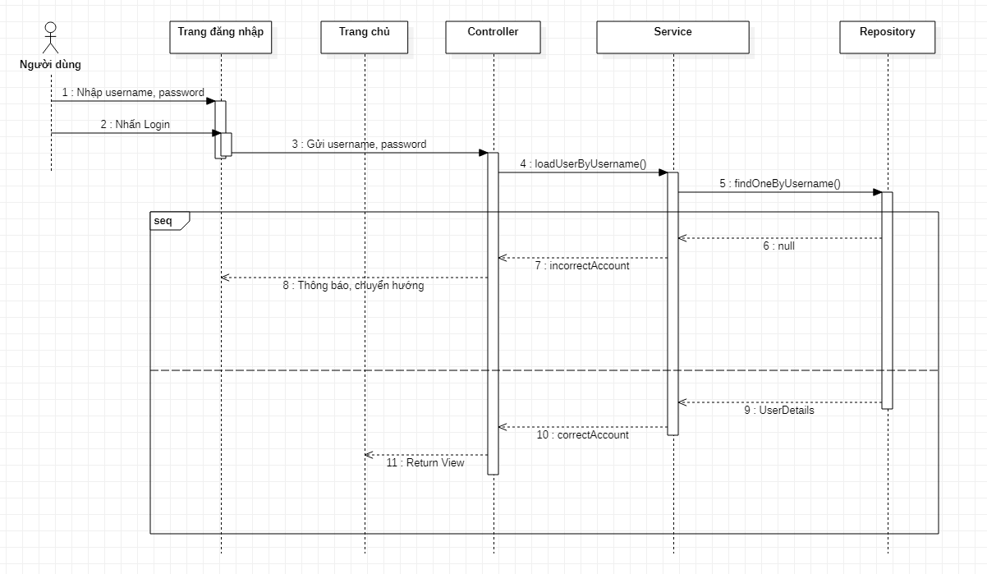

### Danh sách sản phẩm

### Tìm kiếm

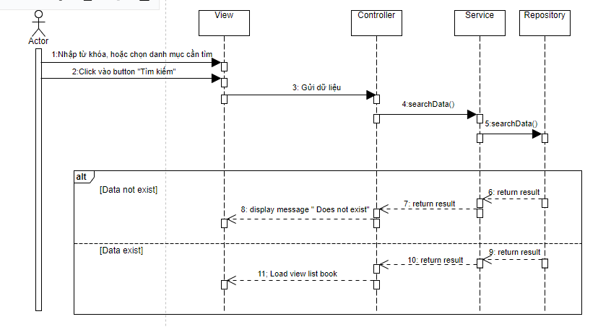

### Đăng kí thẻ thư viện

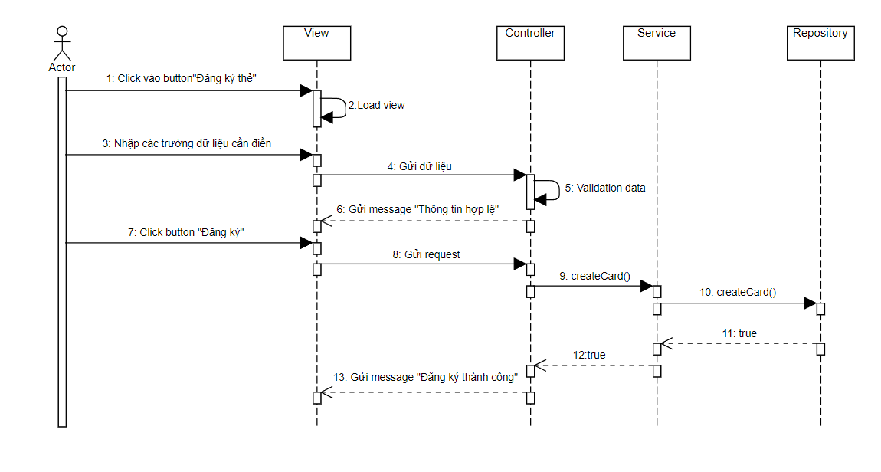

### Mượn sách

### 

### Quản lý mượn sách

#### Thêm

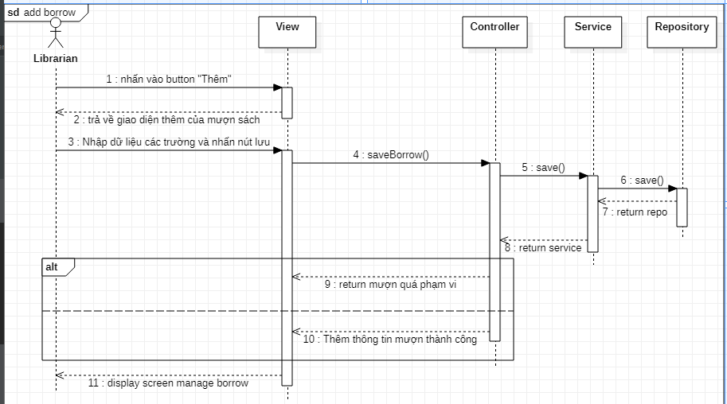

#### Sửa

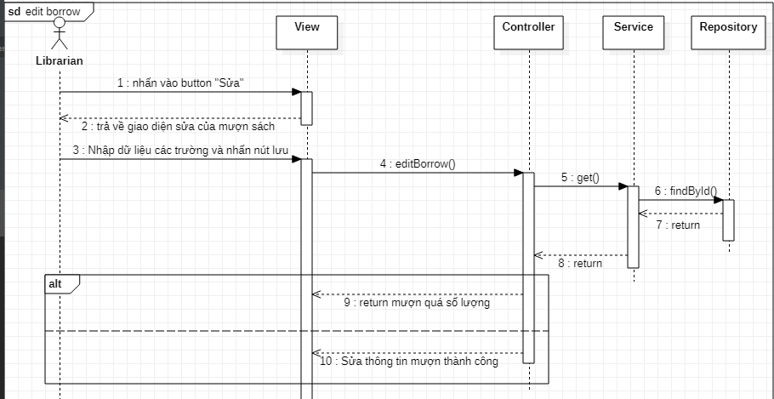

#### Xóa

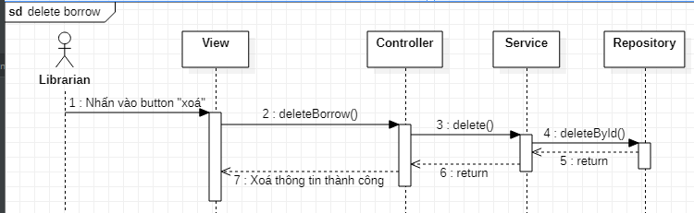

### Quản lý người dùng

#### Thêm user

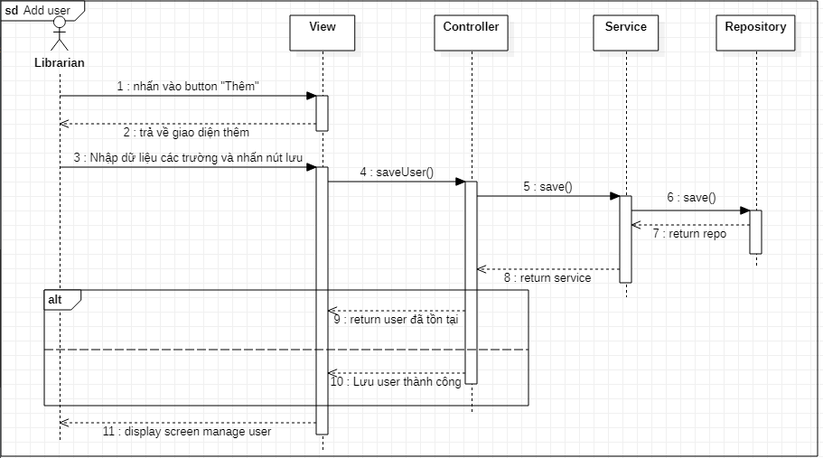

#### Sửa user

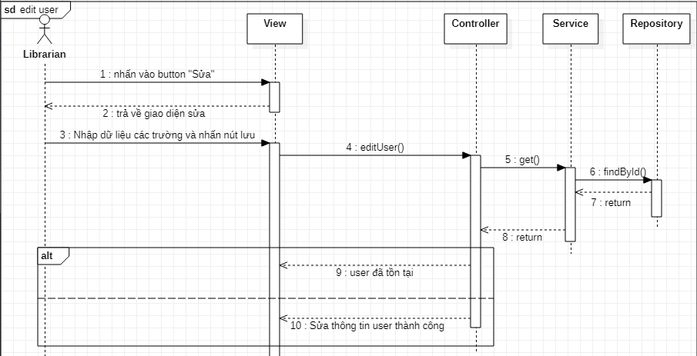

#### Xoá user

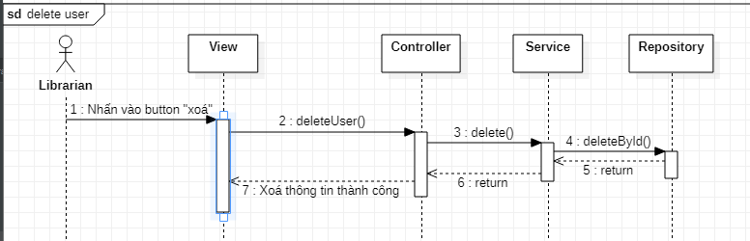

## Screen

### Đăng ký

#### Main flow

| **Screen** |  |
| --- | --- |
| **Description** |  |
| **Screen Access** |  |

#### User interface

* Filter section
* List data section

#### Validation Rule/Data mapping

| **Field** | **Type** | **Description** |
| --- | --- | --- |
| Airline Name | Dropdown list | * Airline Name – Airline Code * Value default is ‘All’ * Display both name and code but name first, value is code * ordered by AIRLINE.NAME * Mapping to field in DB: AIRLINE_INFO. AIRLINE_CODE |
| Filter | Button | * List data in DB withSoftware High Level Design Document_Sample.doc criteria |
|  |  |  |
| Airline Code | Link | * Airline code   Only display as link if user is Administrator or Normal User   * Mapping to field in DB: AIRLINE_INFO. AIRLINE_CODE |
| Airline Name | Label | * Name of Airline * Mapping to field in DB: AIRLINE_INFO. AIRLINE_NAME |
| Wholesaler PCC | Label | * An agent of Customer * Mapping to field in DB: AIRLINE_INFO. WHOLESALER_PCC |
| Contact Number | Label | * Contact number of airline * Mapping to field in DB: AIRLINE_INFO. CONTACT_NBR |
| Email | Label | * Email * Mapping to field in DB: AIRLINE_INFO. EMAIL |
| Add | Button | * Add button   Only display if user is Administrator or Normal User   * Go to the add screen |

### Đăng nhập

#### Main flow

| **Screen** |  |
| --- | --- |
| **Description** |  |
| **Screen Access** |  |

#### User interface

#### Validation Rule/Data mapping

| **Field** | **Type** | **Description** |
| --- | --- | --- |
| Airline Code | Textbox | * Airline Name – Airline Code * Must be alpha numeric (5), is mandatory * Insert to field in DB: AIRLINE_INFO. AIRLINE_CODE |
| Airline Name | Textbox | * Name of Airline * Must be String (45), is mandatory * Insert into field in DB: AIRLINE_INFO. AIRLINE_NAME |
| Wholesaler PCC | Textbox | * An agent of Customer * Must be alpha numeric(5) * Insert into field in DB: AIRLINE_INFO. WHOLESALER_PCC |
| Contact Number | Textbox | * Contact number * Must be number (15), is mandatory * Insert into field in DB: AIRLINE_INFO. CONTACT_NBR |
| Email | Textbox | * Email of airline * Must be String (50) with email format eg.vietnv@gmail.com * Insert into field in DB: AIRLINE_INFO. EMAIL |
| Clear | Button | * Clear button * Clear all inputted data |
| Add | Button | * Add button * Insert new record in database |
| Cancel | Button | * Cancel button * Cancel to add new and back to list screen |

### 1.3.3 Danh sách sản phẩm

### 1.3.4 Tìm kiếm

### 1.3.5 Đăng kí thẻ thư viện

### 1.3.6 Mượn sách

# 1.3.6.1 Main flow

| **Screen** | Mượn sách |
| --- | --- |
| **Description** | Làm cho quá trình mươn sách diễn ra nhanh hơn, thuận tiện hơn |
| **Screen Access** | Độc giả ấn vào **mượn sách** trên thanh menu |

# 1.3.6.2 User Interface

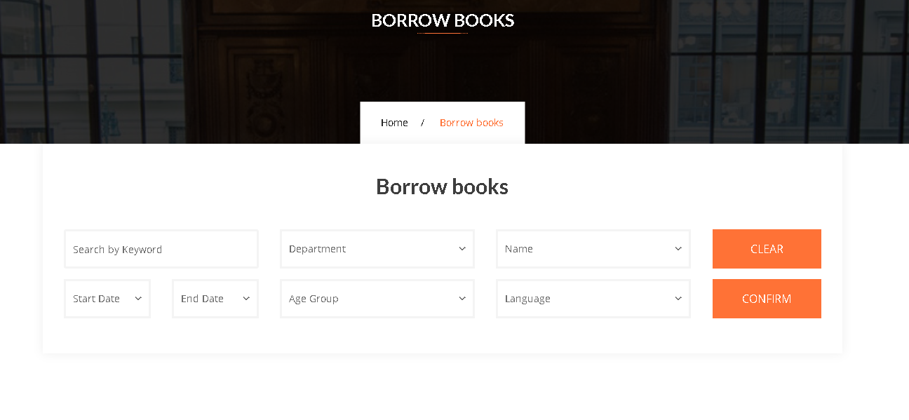

# 1.3.6.3 Validation rule/ Data mapping

| **Field** | **Type** | **Description** |
| --- | --- | --- |
| Airline Code | Textbox | * Airline Name – Airline Code * Must be alpha numeric (5), is mandatory * Insert to field in DB: AIRLINE_INFO. AIRLINE_CODE |
| Airline Name | Textbox | * Name of Airline * Must be String (45), is mandatory * Insert into field in DB: AIRLINE_INFO. AIRLINE_NAME |
| Wholesaler PCC | Textbox | * An agent of Customer * Must be alpha numeric(5) * Insert into field in DB: AIRLINE_INFO. WHOLESALER_PCC |
| Contact Number | Textbox | * Contact number * Must be number (15), is mandatory * Insert into field in DB: AIRLINE_INFO. CONTACT_NBR |
| Email | Textbox | * Email of airline * Must be String (50) with email format eg.vietnv@gmail.com * Insert into field in DB: AIRLINE_INFO. EMAIL |
| Clear | Button | * Clear button * Clear all inputted data |
| Add | Button | * Add button * Insert new record in database |

### 

### 1.3.7 Quản lí mượn sách

### 1.3.8 Quản lí người dùng